Sprint 2 Plan

Pix Paint

Blair O’Brien, Daniel Phelps, Likha Pulido, Jennifer Chen, Christy Miao

Revision: 3

Revision Date: 4/30/2024

Completion Date: 5/7/2024

# Goals

* Canvas presence (100 x 100 px)
* File opening functionality
* File saving functionality
* Pen/pencil tool with adjustable size and opacity
* Eraser tool with adjustable size and opacity

# Tasks

* User-story 2: As a program-user, I want to create/open/save/export a canvas that can have its dimensions set before/after creation.).
  + Opening/Saving/Exporting PNG/PIX
    - PNG
      * Task 1: Implement pseudo code
      * Task 2: Connect with UI
        + ~~Implement CTRL + S saving~~
        + ~~Implement Open on menu~~
        + ~~Implement Saving on Workspace~~
        + ~~Implement Open on Workspace~~
        + ~~Implement CTRL + O open~~
        + ~~Implement New on Workspace~~
        + ~~Implement CTRL + N new canvas~~
        + Implement Export on Workspace

~~Current size, Resize, Download menu~~

Should not change current file extension/most recently used path

* + - PIX
      * Task 1: Research how to do
      * Task 2: Implement
  + Resize Canvas
    - Task 1: Connect global canvas_size var to canvas size
* User-story 3: As a program-user, I want to use pen and eraser tools that can have their sizes/opacities adjusted.
  + Task 1: Research how to adjust pen/eraser size/opacity
  + Task 2: Demo
  + Task 3: Connect to global variables and implement into broader project
* User-story 4: As a program-user, I want to access colors from a color wheel to change the pen color.
  + Task 1: Implement changing pen’s color
  + Task 2: Implement ability to blend colors

# Team Roles

* Blair O’Brien: Project Owner/ Team Member/ Product Owner
* Daniel Phelps: Team Member
* Likha Pulido: Scrum Master/ Team Member
* Jennifer Chen: Team Member
* Christy Miao: Team Member

# Task Assignment

* Blair O’Brien:
  + User-story 2: Implement pseudo code
  + User-story 2: Connect with UI
* Daniel Phelps:
  + User-story 2: Research project opening/save
  + User-story 2: Implement project opening/save
* Likha Pulido:
  + User-story 2: Connect global canvas_size to actual canvas
* Jennifer Chen:
  + User-story 3: research how to increase pen/eraser size
* Christy Miao:
  + User-story 3: research how to change pen/eraser opacity + implement

# Burnup Chart

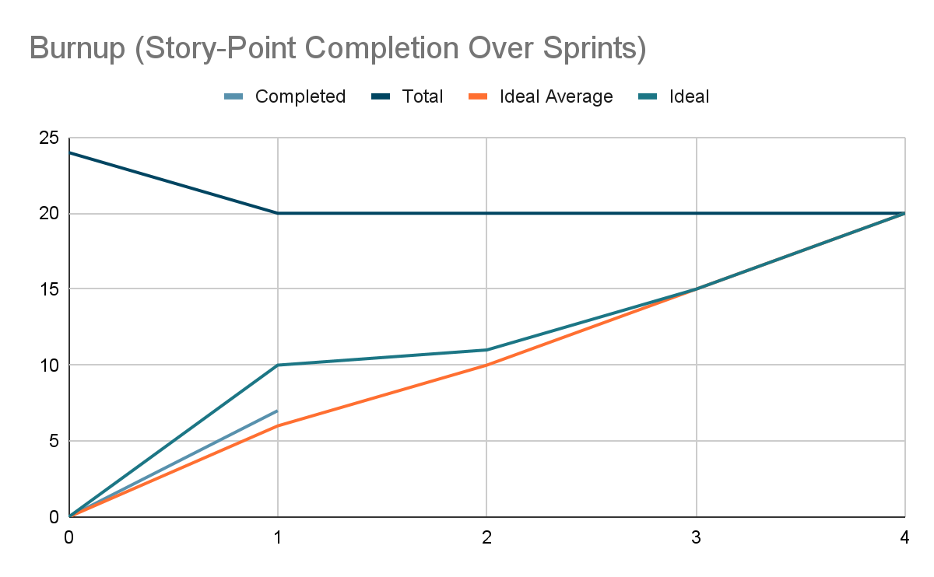

# Scrum Board

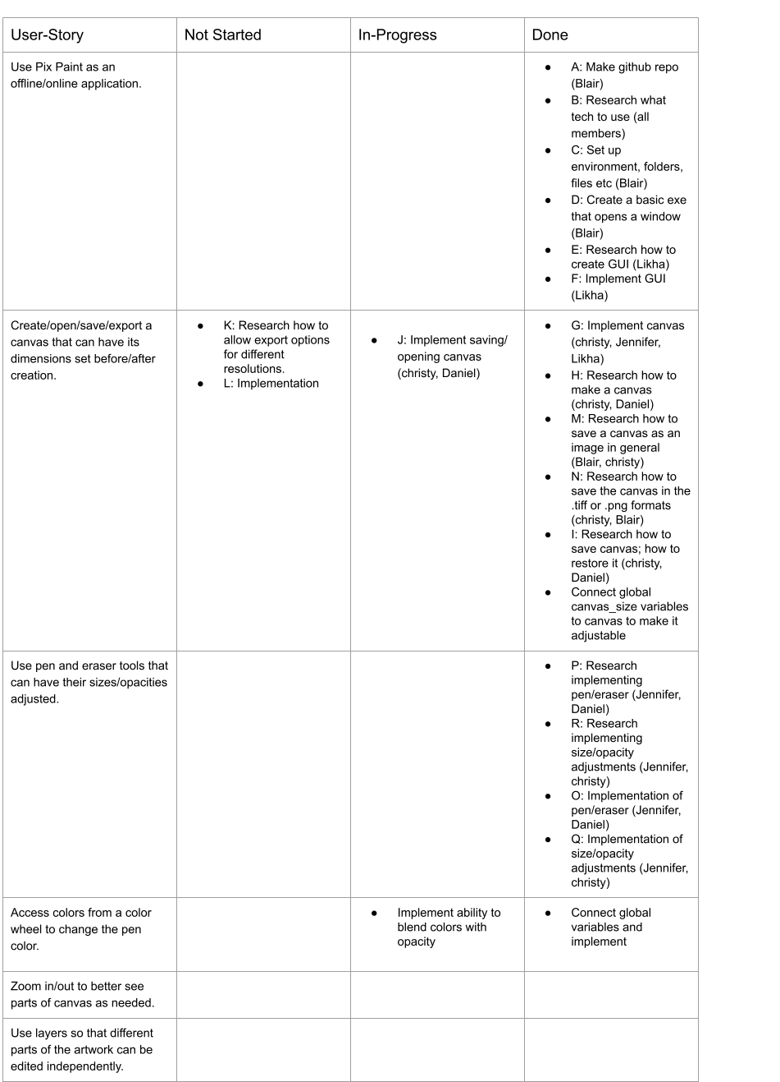

# Scrum Times

| Day | Time |
| --- | --- |
| Monday (SCRUM meeting) | 1:30 PM - 1:45 PM |
| Wednesday (SCRUM meeting) | 1:30 PM - 1:45 PM |
| Thursday (meeting with TA) | 9:00 AM - 10:00 AM |
| Thursday (Development meeting) | 10:30 AM - 11:30 AM |
| Friday (SCRUM meeting) | 1:30 PM - 1:45 PM |
| Sunday (Development meeting) | 10:30 AM - 11:30 AM |